**Exercises:**

Asking user input a word or phrase and store it into a char array. Then do the following work:

1. Reverse the array
2. Display the original array
3. Display the reversed array

Sample output:

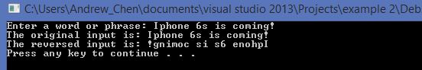

*Make sure to declare the array which has enough room for the input.

*Remember to set the end point to your reverse array.

*You can use more than one array to complete the job.

More challenge?

Try to complete the project by using 1 array only.